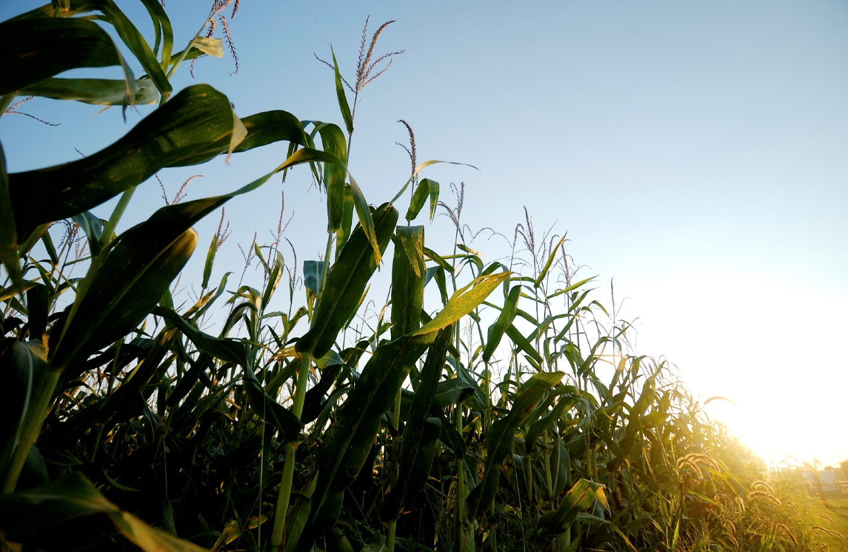

**Nonprofit**

**Needs**

**Report**

**3rd Quarter 2016**

**Washington County Friends of the Fair**

**Project:** Rybin Building Restroom Modernization and ADA Compliance Project

**Total Project Cost:** $40,000

**Amount Requested:** $25,000

**Amount Awarded**: $15,000

The Rybin Building on the Washington County Fairgrounds was constructed in the early 1980’s and the restroom facilities are original and in major need of repair. These facilities are not ADA accessible and they need to be updated to accommodate visitors with special needs. This facility serves thousands of visitors each year and is the only air conditioned building on the grounds. It serves as a hub during the Washington County Fair. Grant funds will be used to make necessary updates.

**Prague Improvement and Maintenance Project**

**Project:** Village of Prague Park Renovation

**Total Project Cost:** $135,000

**Amount Requested:** $10,000

**Amount Awarded**: $10,000

This organization is sponsoring a park renovation project. The current playground equipment is dated and several small children have been injured as a result. Funds received will help upgrade the park equipment, make the entire facility ADA accessible, and improve this community hub for all of Prague to enjoy.

**Salem Little Saints Christian Child Care Center**

**Project:** New Playground

**Total Project Cost:** $69,069.19

**Amount Requested:** $20,700

In January of 2014 the center expanded by three classrooms and also changed its licensing capacity from 60 children to 100, while still keeping the age range of 6 weeks to 13 years. With the expansion of the center, the playground also needs to be expanded. Currently, it is not developmentally appropriate for all ages that are using it. The playground is designed for ages 3-13 but is used by children as young as one. Grant funds will provide equipment that would meet the proper development needs of every child using the playground.

**Fremont Area Habitat for Humanity**

**Project:** Addition to Building

**Total Project Cost:** $30,000

**Amount Requested:** $20,000

The Fremont Area Habitat for Humanity has been in its current location for two years, and due to generous donations to its HomeStore, has already started to outgrow its existing building area. The organization’s plan is to build a 1,320 square foot addition to the front of the building and add a 750 square foot fenced-in area on the east side of the building. Its goal is to alleviate the overflow in the receiving area, eliminate the need for storage units, and ultimately increase HomeStore sales which, in turn, provide funding to build homes.

**Dodge County 4-H Foundation**

**Project:** New Livestock Pavilion and New Restroom

**Total Project Cost:** $214,000

**Amount Requested**: $45,000

**Amount Awarded**: $10,500

The purpose of this project is to help fund the expansion and improvement of the livestock arena at the Dodge County Fairgrounds in Scribner, including a new livestock pavilion and restrooms for the Dodge County 4-H members, their families and fair patrons. The building would also serve other 4-H and FFA events throughout the year to expand the reach to area youth.

**Fremont Area Art Association**

**Project:** Expand Our Vision

**Total Project Cost:** $174,845

**Amount Requested**: $48,000

**Amount Awarded**: $28,000 matching grant

The Fremont Area Art Association is in the process of purchasing the Rump’s building adjacent to Gallery 92 West. The immediate plan is to open up the shared wall creating a fully accessible classroom/studio space in the new building. Funds raised will expand programming throughout the space to better serve the needs of the community.

**City of North Bend**

**Project:** New Park Shelter

**Total Project Goal:** $250,125

**Amount Requested:** $45,000

**Amount Awarded**: $2,500

Funds will support the replacement of the current metal park structure with a 30’ x 50’ block shelter. The new shelter will feature cement counters, metal roll up windows, ceiling fans, a hot water heater, sinks and a refrigerator—a much-improved facility for many of the town’s events held there throughout the year including the annual Old Settler’s celebration, reunions, birthday parties, church gatherings and picnics.

**Set Me Free Project**

**Project:** Human Trafficking Awareness

**Total Project Cost:** $198,100

**Amount Requested:** $10,000

The objective of this project is to raise awareness of the hidden, yet flourishing, sex trade in our area, with a curriculum to educate the most vulnerable population–our youth. The Set Me Free Project goes directly into school classrooms to educate middle school and high school youth on the dangers of human trafficking and social media safety.



**Our mission is to connect**

**donor interests**

**with**

**community needs**

We invite you to review grant projects recently submitted to and reviewed by the Foundation Grants Committee. If you would like additional information or wish to support any of these projects through your Donor-Advised Fund, please contact Melissa Diers at (402) 721-4252 or [mdiers@facfoundation.org](mailto:mdiers@facfoundation.org).

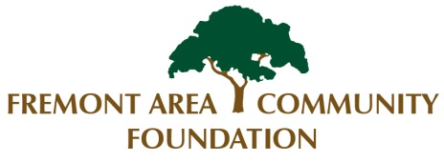

*Do you have a passion for the arts, education, youth programming or something else? If so, please let us know so that we can keep you informed of community needs and opportunities within your charitable area of interest. Contact Melissa at*

*(402) 721-4252 or mdiers@facfoundation.org.*